Sex Differences in Mathematics and Reading Across Italy:
The Role of Socioeconomic Factors
Supplementary Materials

Additional information on Preliminary analysis
Figure S1
Forest plot of provinces effects for mathematics in grade 2
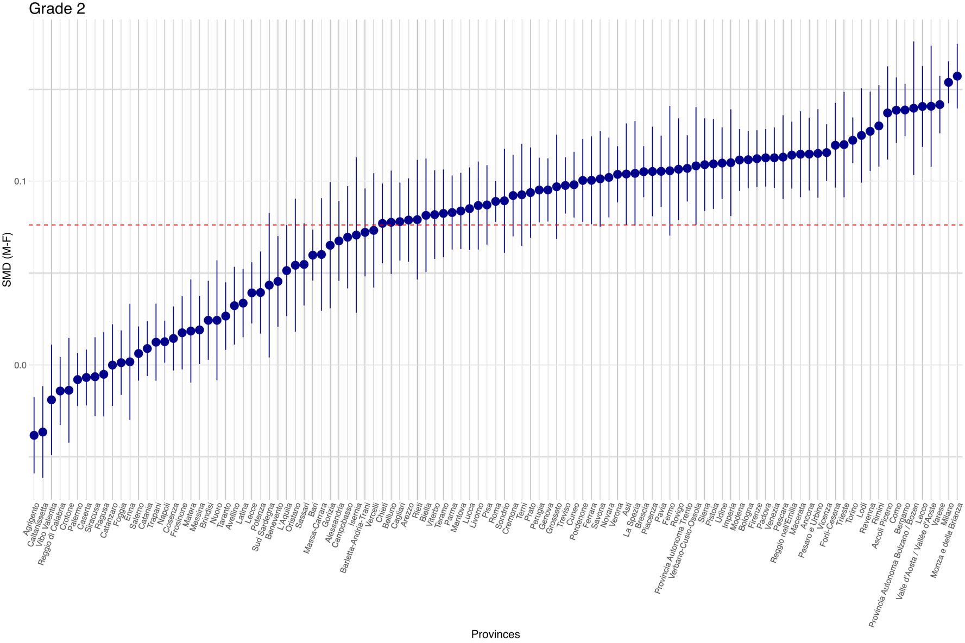
Figure S2
Forest plot of provinces effects for mathematics in grade 5
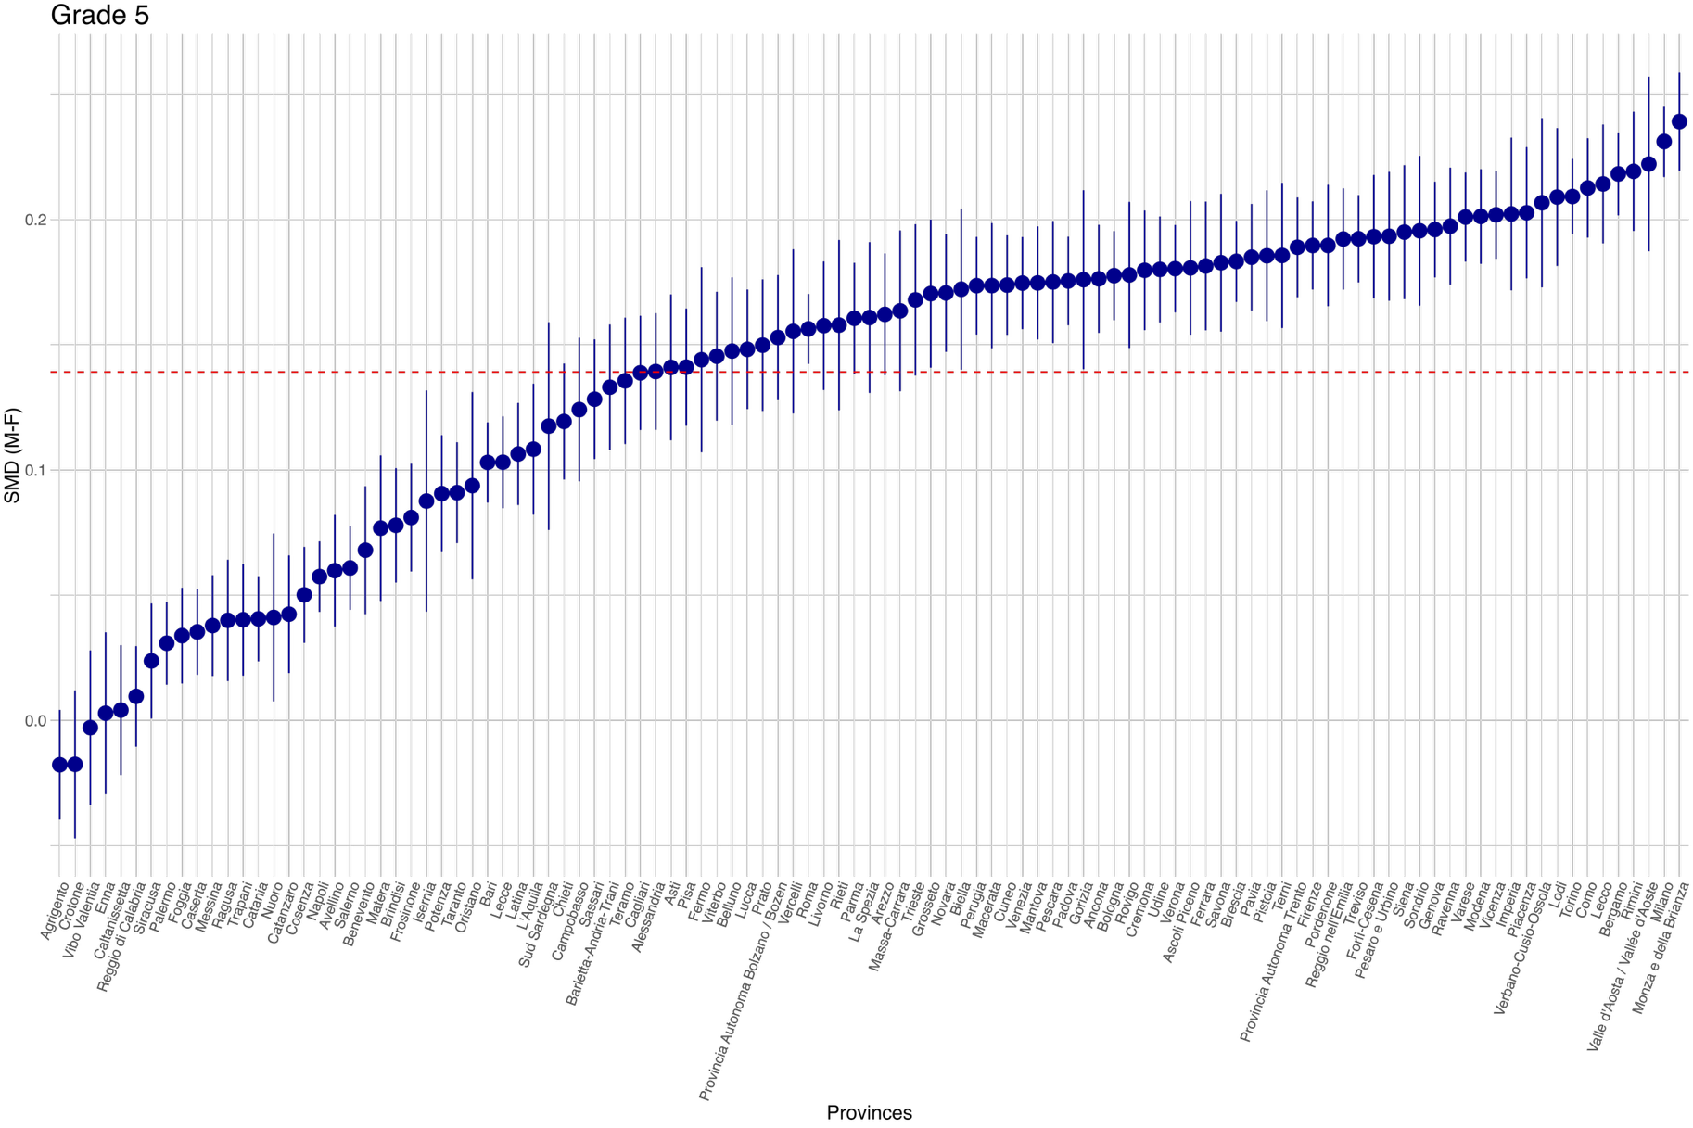

Figure S3
Forest plot of provinces effects for mathematics in grade 8
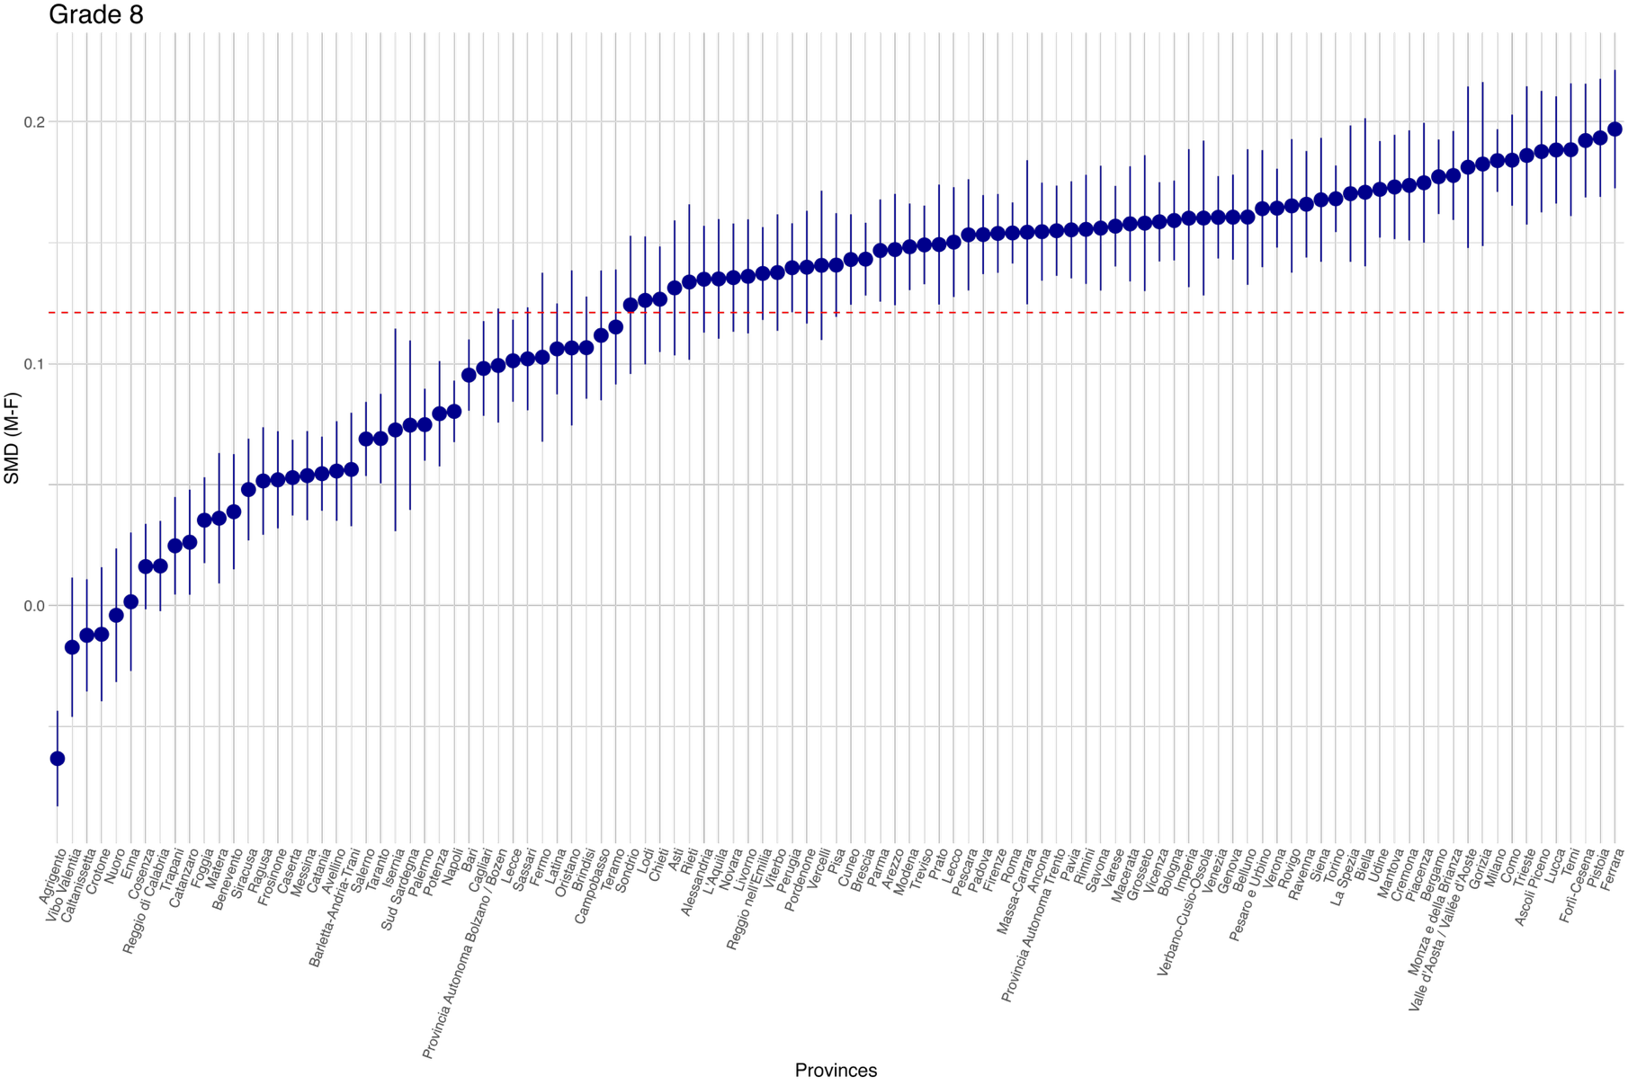

Figure S4
Forest plot of provinces effects for mathematics in grade 10
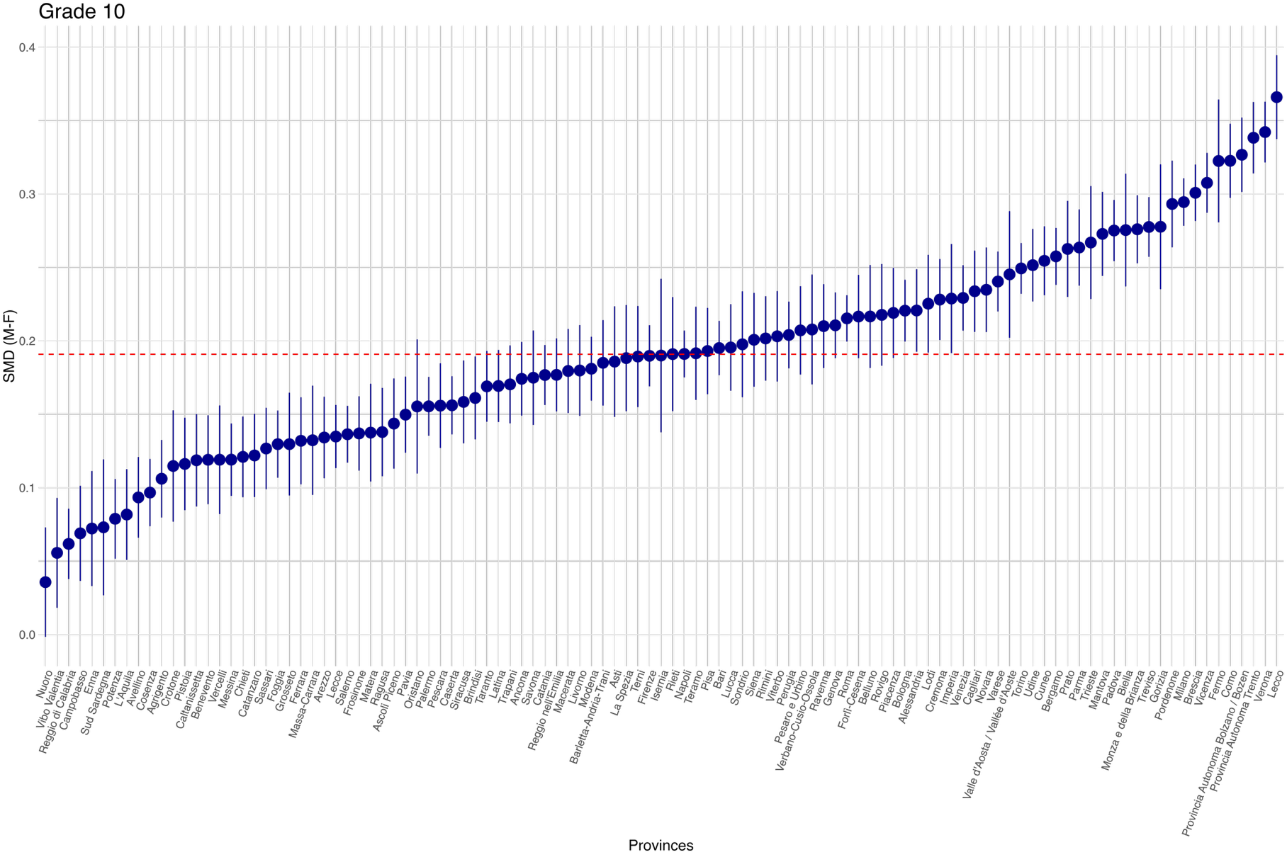

Figure S5
Forest plot of provinces effects for mathematics in grade 13
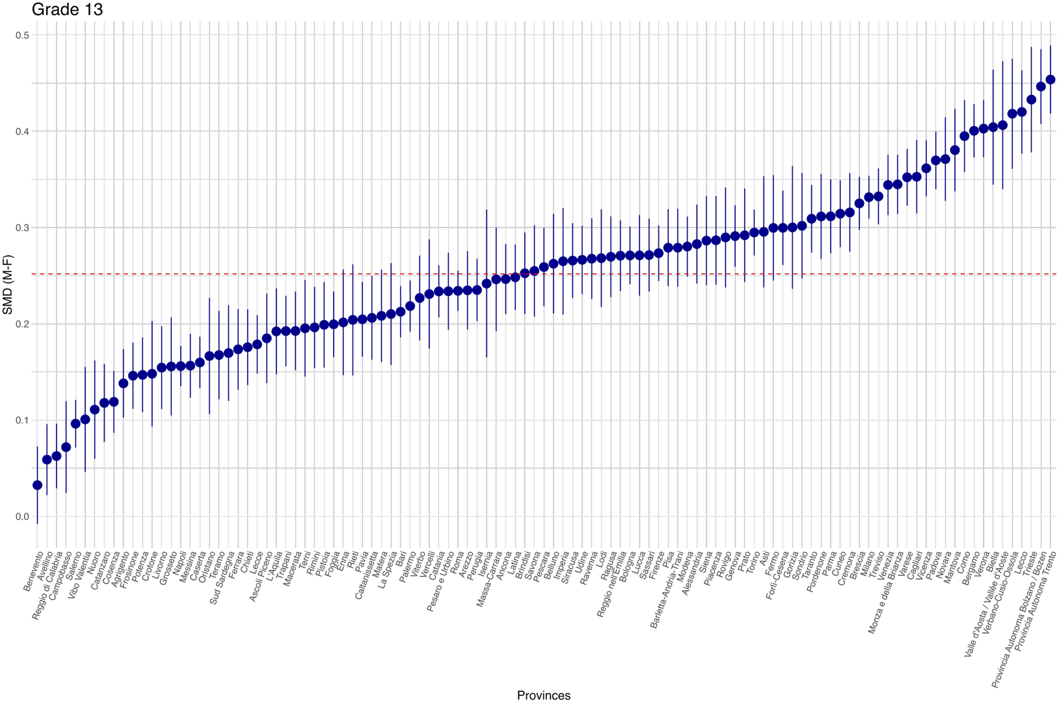

Figure S6
Forest plot of provinces effects for reading in grade 2
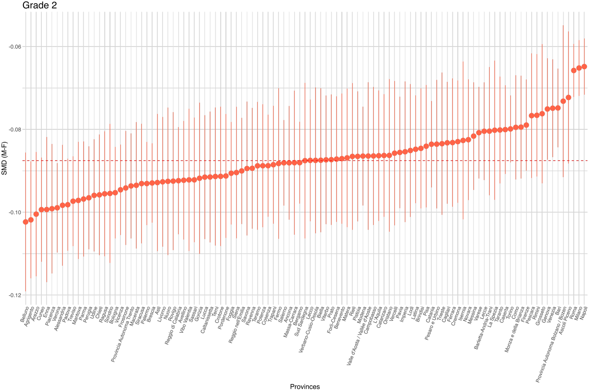

Figure S7
Forest plot of provinces effects for reading in grade 5
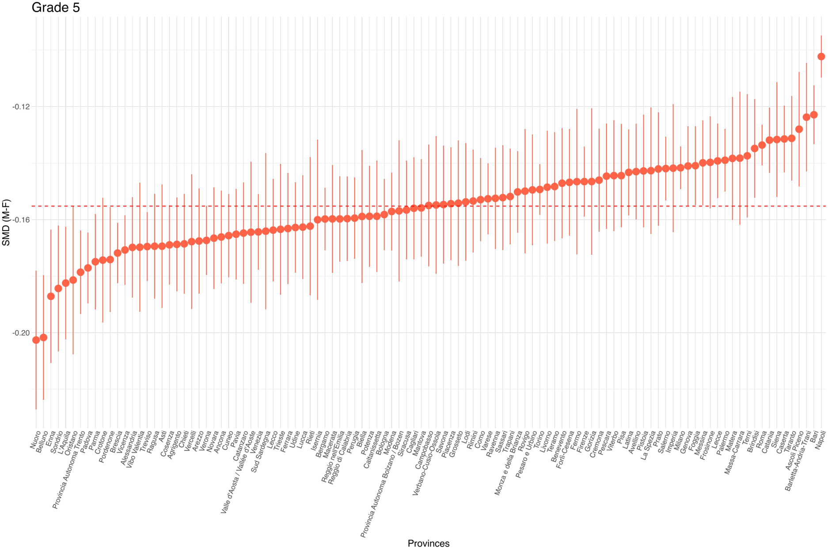

Figure S8
Forest plot of provinces effects for reading in grade 8
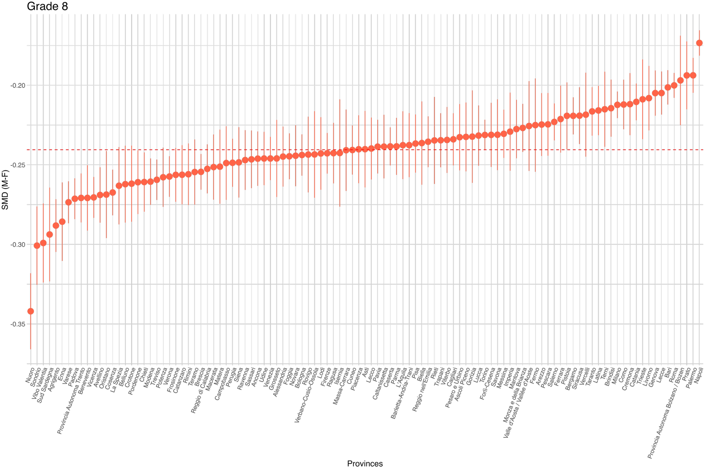
Figure S9
Forest plot of provinces effects for reading in grade 10
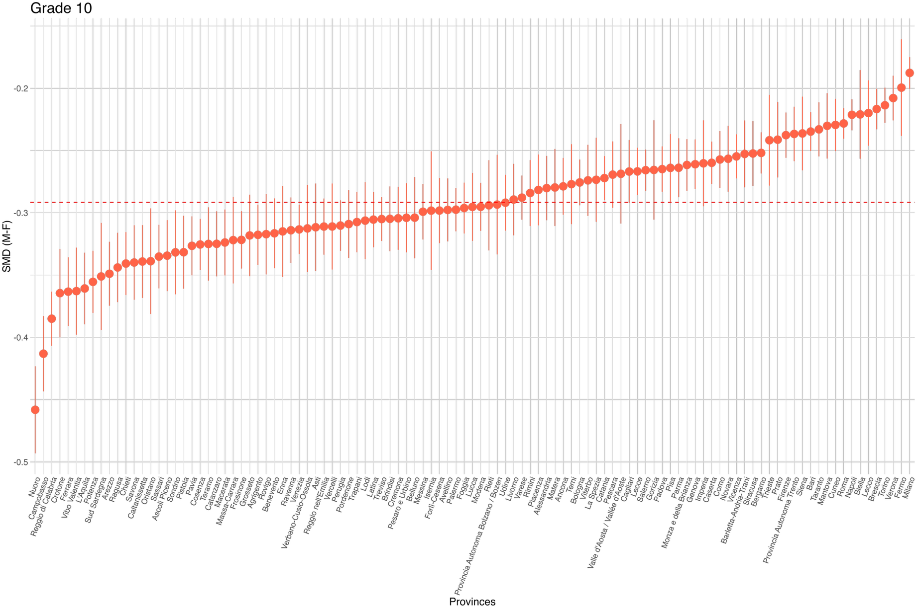
Figure S10
Forest plot of provinces effects for reading in grade 13
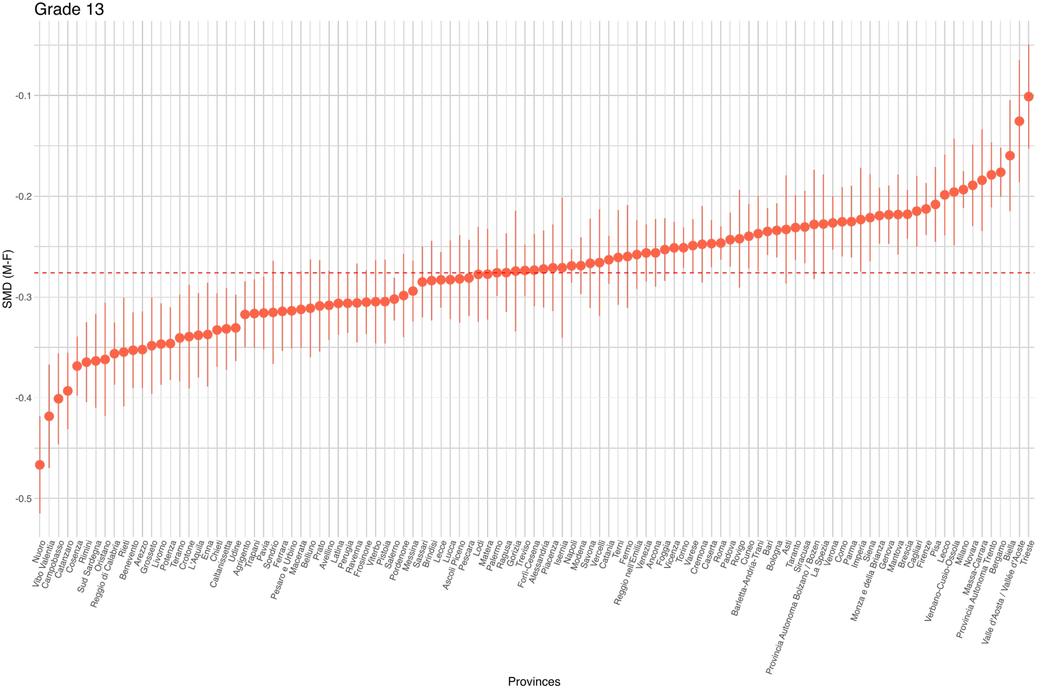

Additional information on Analysis of moderators
As shown in Table S1 below, all VIF values remained well below the conservative threshold of 5. The highest VIF observed was 4.393 for mean added value in the mathematics model, while the VIF for the geographical gradient was 3.996. These results indicate that while there is shared variance among economic and geographical indicators, consistent with the correlation analysis, there is no severe multicollinearity that would necessitate the a priori exclusion of variables.

Table S1
VIF for each candidate moderator for mathematics and reading (left) and correlations (right)
Moderator | Mathematics | Reading | 1. | 2. | 3. | 4. | 5. | 6. | 7.
1. Geographical Gradient | 3.996 | 3.658 | 1
2. Employment Rate Ratio | 3.672 | 3.572 | -.750 | 1
3. University Enrollment Ratio | 2.629 | 2.421 | .570 | -.601 | 1
4. Added Value | 4.393 | 4.297 | -.744 | .800 | -.742 | 1
5. Wages Ratio | 1.796 | 1.808 | .565 | -.512 | .422 | -.663 | 1
6. Women in administrations | 1.348 | 1.436 | -.164 | .313 | -.360 | .342 | -.225 | 1
7. STEM Track Choice | 1.126 | 1.103 | .147 | -.118 | -.004 | -.010 | -.023 | -.222 | 1
8. Mean Achievement | 4.039 | 2.527 | -.753 | .670 | -.635 | .794 | -.551 | .242 | -.013

Figure S11
Partial residuals of SMD for mathematics as a function of moderator(s) in the full model.
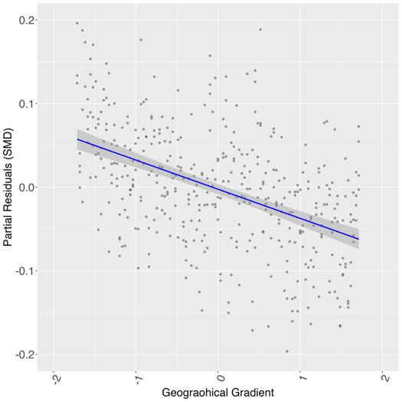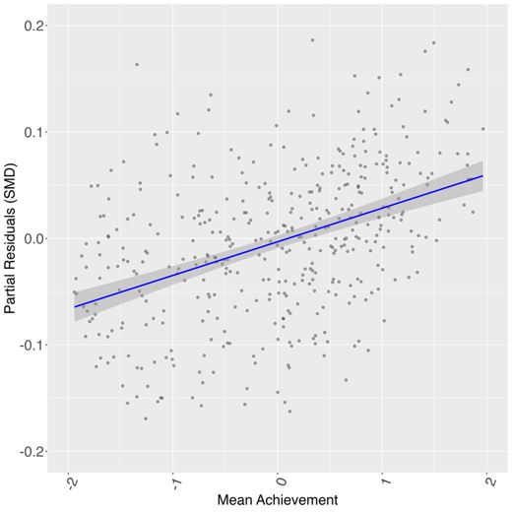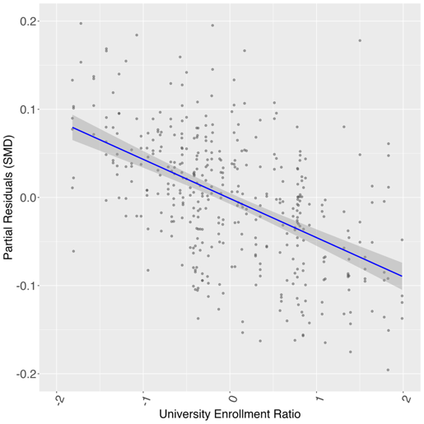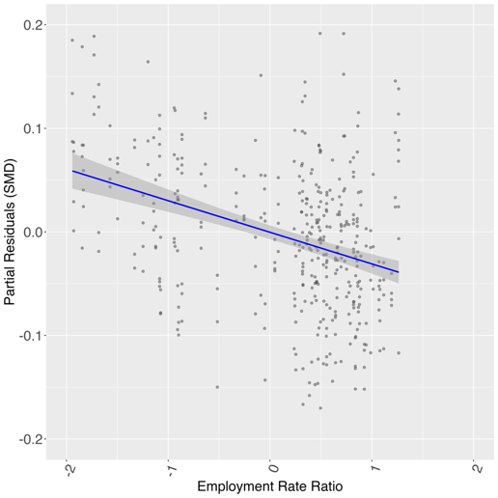

Figure S12
Partial residuals of SMD for reading as a function of moderator(s) in the full model.
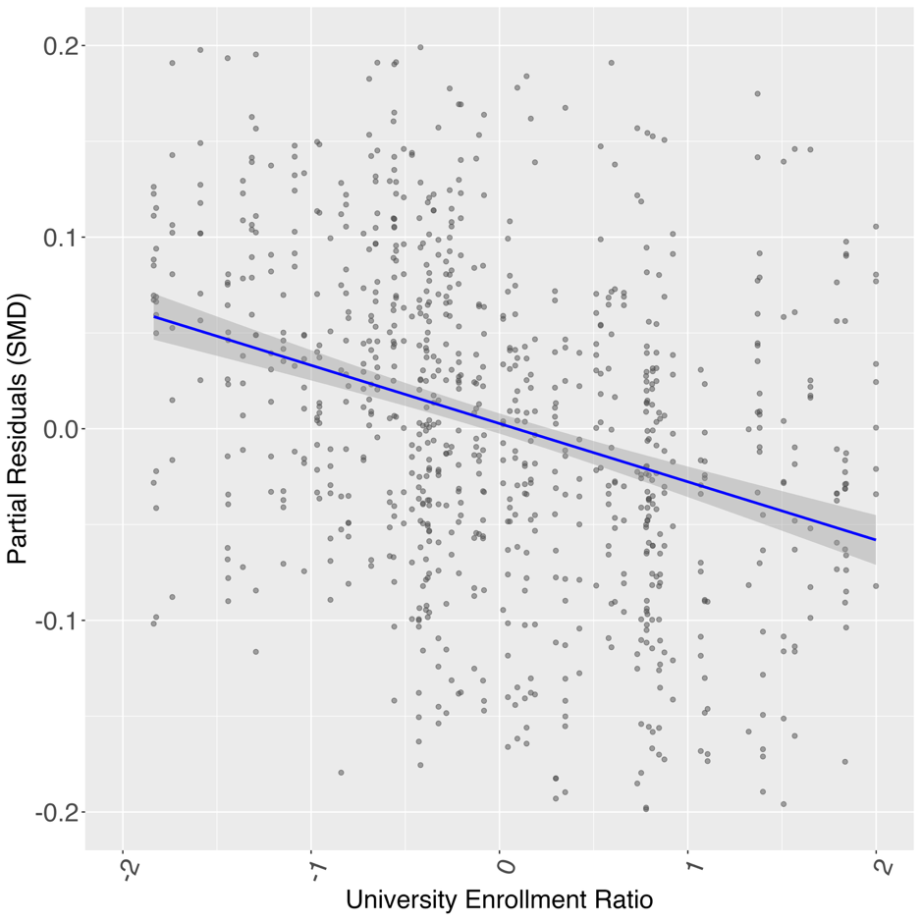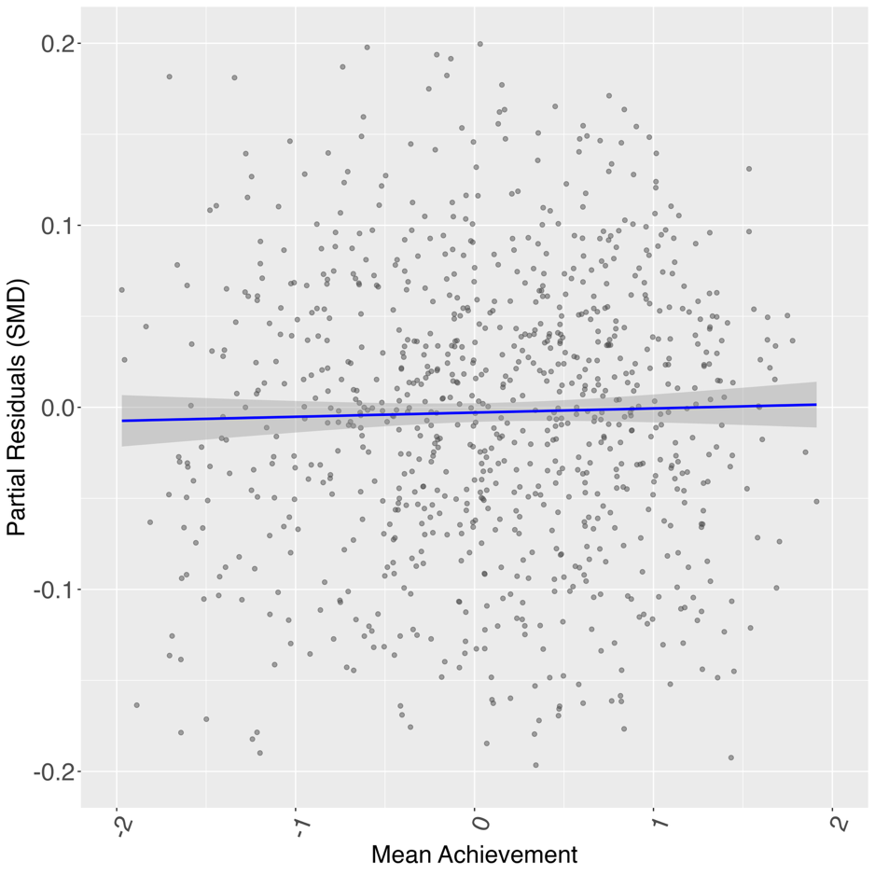

Regarding geographical gradient, the pattern confirms that while both sexes perform better in high-achieving provinces (North), the boys' performance slope is steeper, indicating that the boys' advantage tends to be more pronounced in higher-performing contexts. Conversely, regarding university enrollment, in provinces with higher female-to-male ratios, the achievement gap narrows, driven by a steeper increase in female performance relative to males.

Figure S13
Interaction between mean score at mathematics and sex difference. Provinces are arranged by geographical gradient
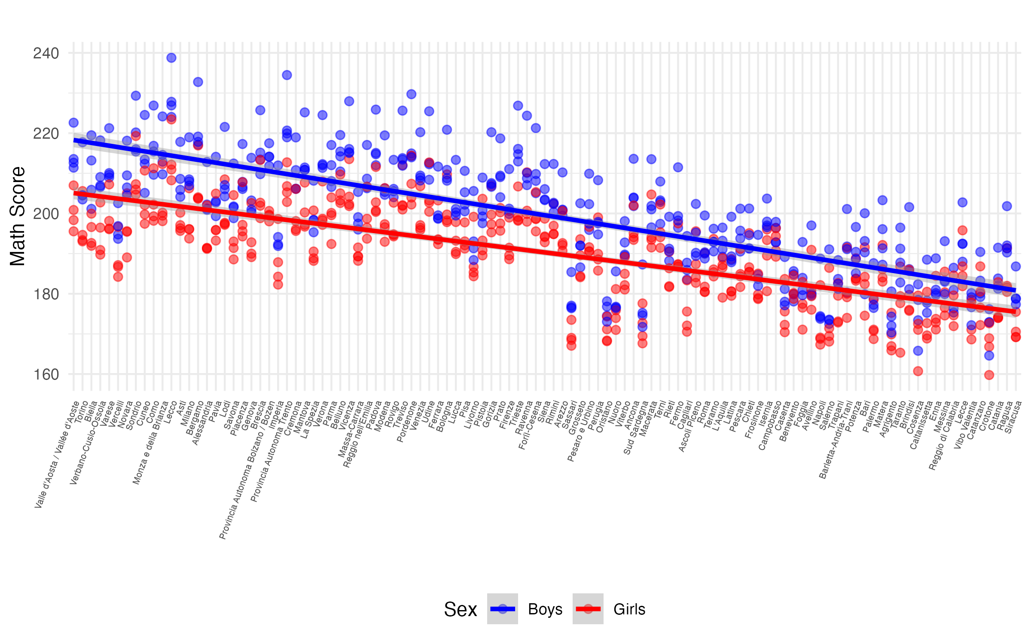
Figure S14
Interaction between university enrollment and sex difference. Provinces are arranged by increasing university enrollment
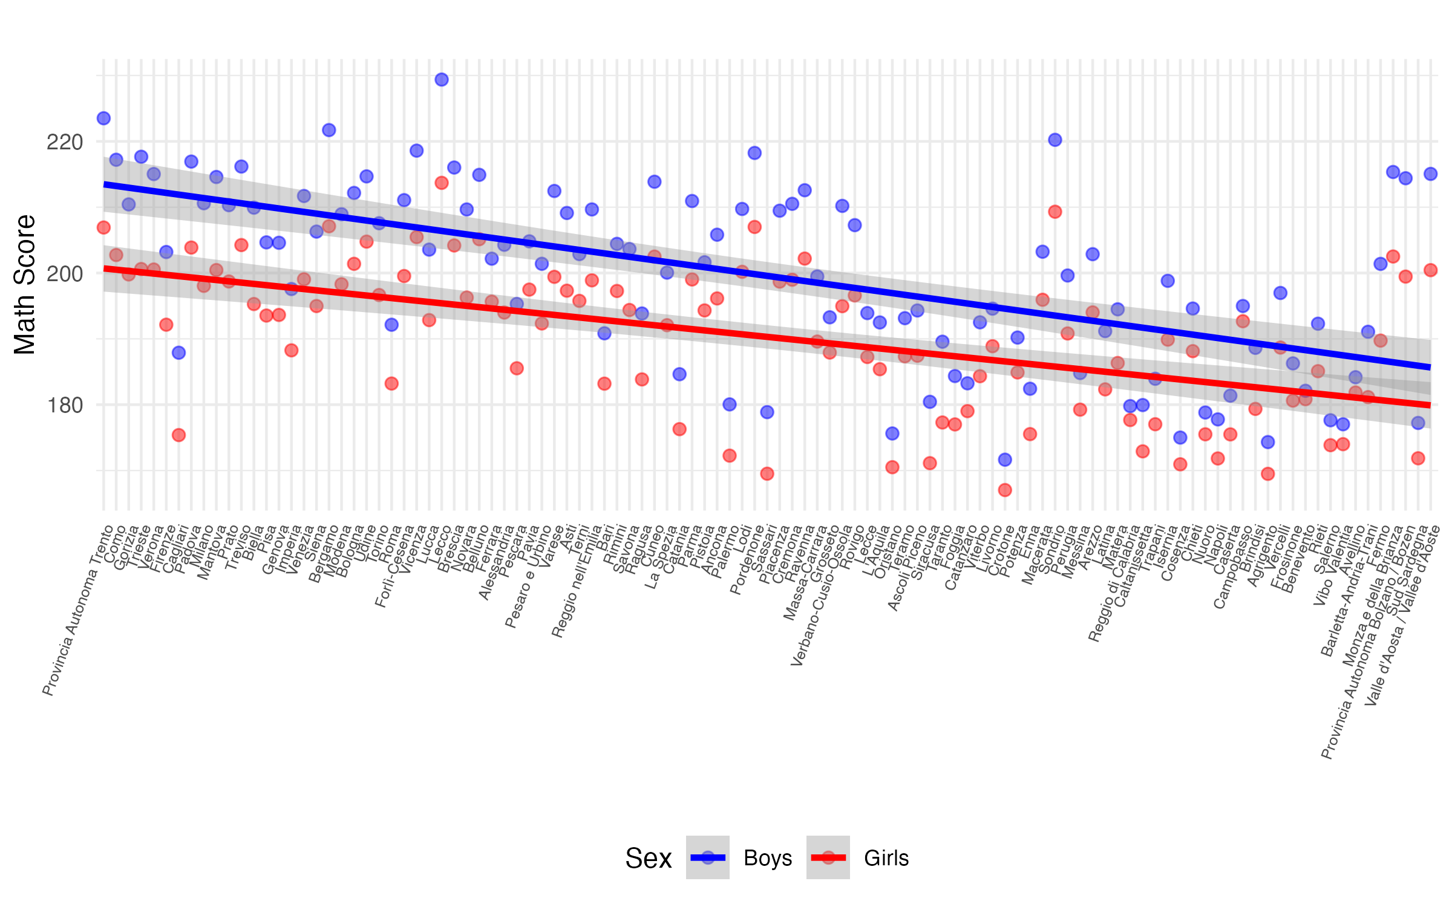

Additional information on Sensitivity Analyses

Ridge meta-regression
As for mathematics, the analysis confirmed the selection of the primary predictors based on their standardized coefficients. University enrollment, β = -0.058, mean achievement score, β = 0.029, geographical gradient, β = -0.029, and employment rate, β = -0.036, exhibited the similar associations, confirming that the model selection was robust to collinearity.
As for reading, The Ridge meta-analysis confirmed the selection of these predictors based on their standardized coefficients: university enrollment ratio, β = -0.033, and mean achievement score, β = -0.021.
Sensitivity Analyses
First, to further test the robustness of these findings against spatial autocorrelation, we replicated the final models in mathematics (grade 13) and reading (grade 10). As for mathematics, the full model, including Employment Rate Ratio, University Enrollment Ratio, and Mean Achievement, was specified this time the spatial structure with a thin-plate spline on longitude and latitude. The spatial smooth term was significant, F(37.47, 49.50) = 3.58, p < .001, capturing the complex geographical heterogeneity. All socio-economic and achievement moderators remained highly significant: the employment rate ratio, β = -0.038, p < .001, the university enrollment ratio, β = - -0.045, p < .001, and the mean achievement score, β = 0.036, p < .001. This confirms that the identified predictors play a robust role in explaining gender differences beyond mere geographical location. Finally, Moran's I on the spatially aggregated residuals confirmed the absence of significant spatial clustering, Moran's I = -0.039, p = .781.
Similarly, for reading, the spatial sensitivity analysis confirmed the robustness of the primary predictors. The spatial smooth term was significant, F(36.27, 48.18) = 5.43, p < .001, indicating strong geographical heterogeneity. Under this specification, the university enrollment ratio remained the strongest and most robust predictor, β = -0.562, p < .001, alongside the mean achievement score, β = -0.014, p = .002. Moran's I on the spatially aggregated residuals confirmed the absence of significant spatial clustering, Moran's I = -0.090, p = .983.
Second, we tested the temporal robustness of the findings by re-fitting the models using year-specific, lagged (t-1) moderators. For the employment rate ratio, data were available for the entire analyzed period (2018–2022). For the university enrollment ratio, data availability restricted the lagged analysis to the 2018 and 2020 waves for mathematics, and to the 2017 and 2018 waves for reading. For mathematics, the lagged multivariate model, BIC = -683.421, τ = 0.054, σ₁ = 0.054, σ₂ = 0.000, ICC₁ = .999, ICC₂ = .000, confirmed that both the employment rate ratio, β = -0.016, SE = 0.007, 95% CI [-0.029, -0.003], p = .013, and the university enrollment ratio, β = -0.010, SE = 0.004, 95% CI [-0.018, -0.002], p = .013, remained significant predictors even when accounting for temporal precedence and controlling for mean achievement. Similarly, for reading, the lagged multivariate model, BIC = -534.988, τ = 0.043, σ₁ = 0.038, σ₂ = 0.019, ICC₁ = .801, ICC₂ = .199, confirmed the robustness of the structural predictors. Specifically, the university enrollment, β = -0.019, SE = 0.005, 95% CI [-0.028, -0.010], p < .001. Finally, a leave-one-out influence analysis confirmed that the results were not driven by specific influential outliers. Iteratively removing each province yielded stable estimates for all key predictors, with coefficients maintaining their direction and effect size.

Figure S15
Leave-one-out results for mathematics (Employment Rate Ratio)
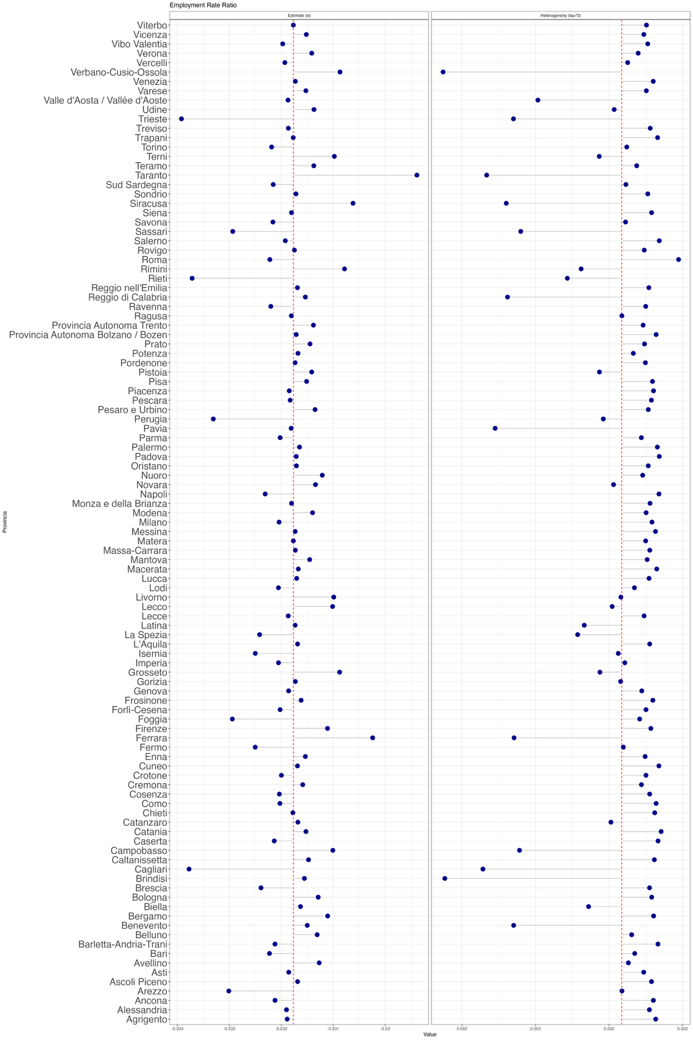

Figure S16
Leave-one-out results for mathematics (Geographical Gradient)
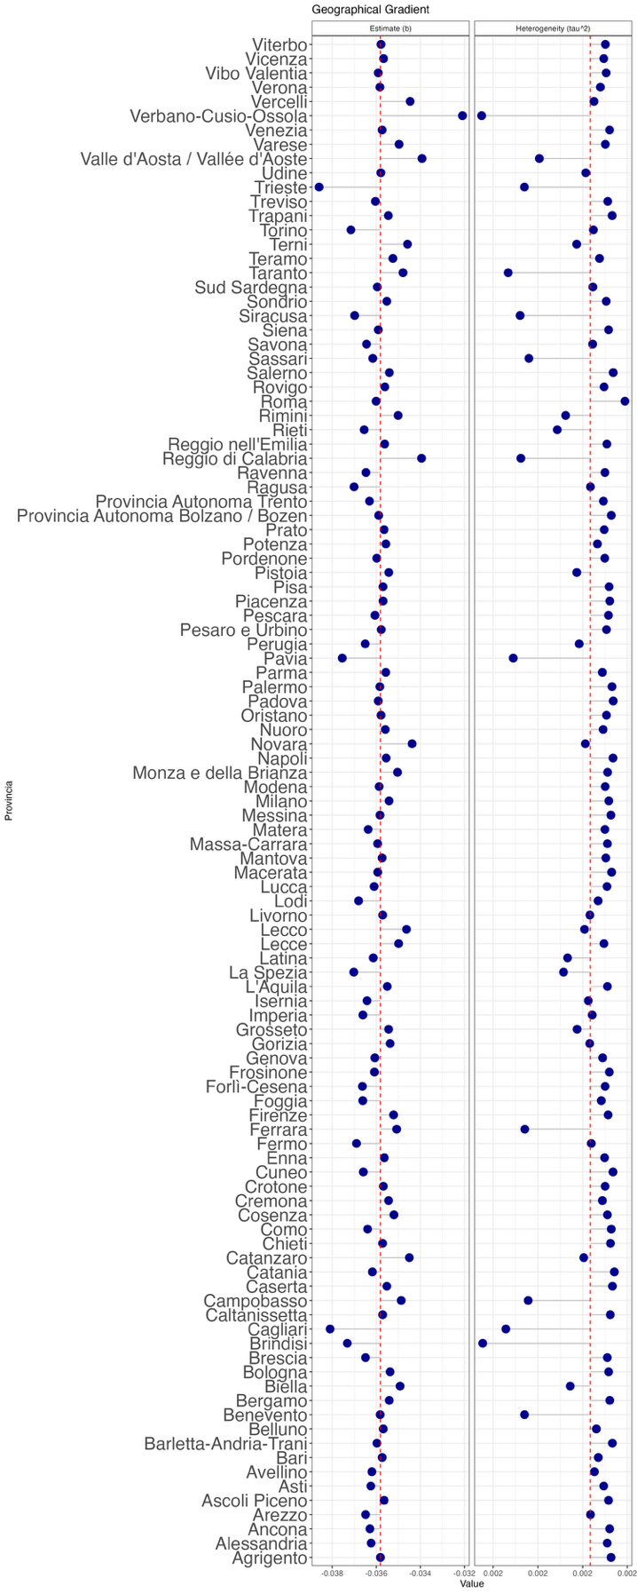

Figure S17
Leave-one-out results for mathematics (Mean Achievement)
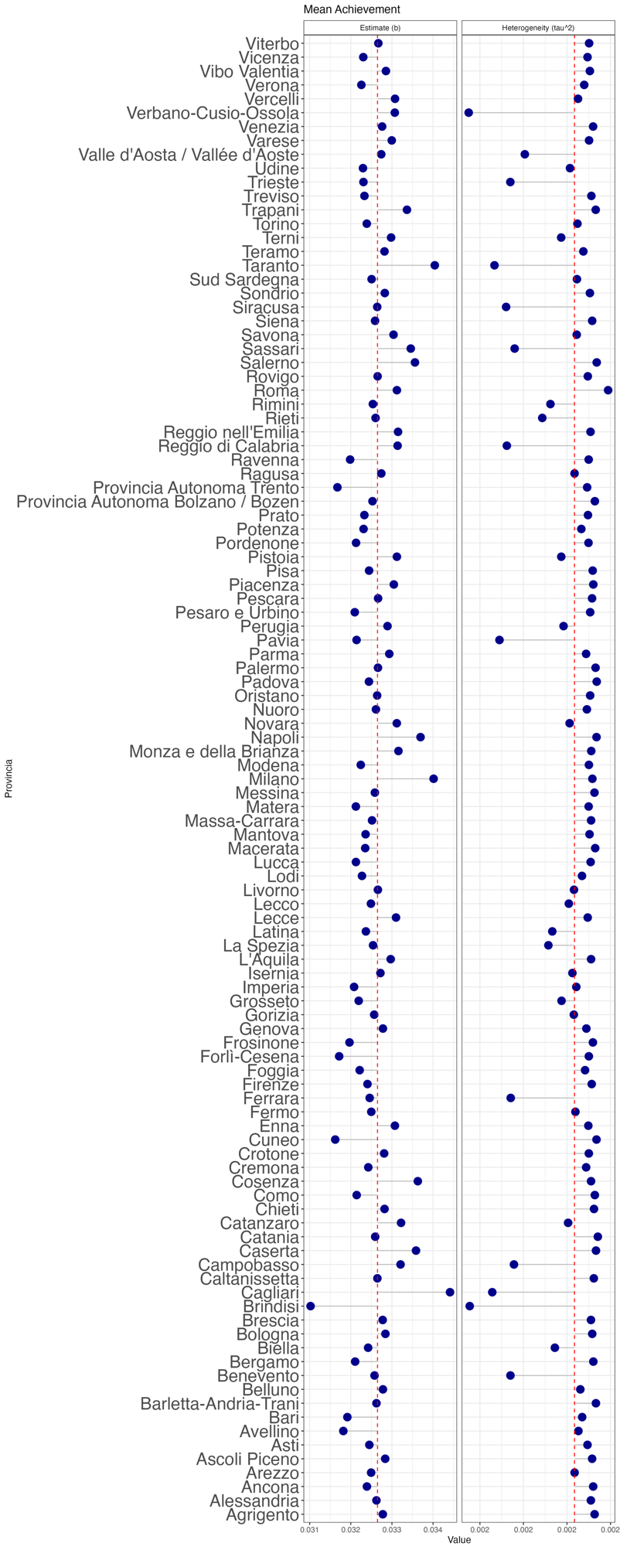
Figure S18
Leave-one-out results for mathematics (University Enrollment Ratio)
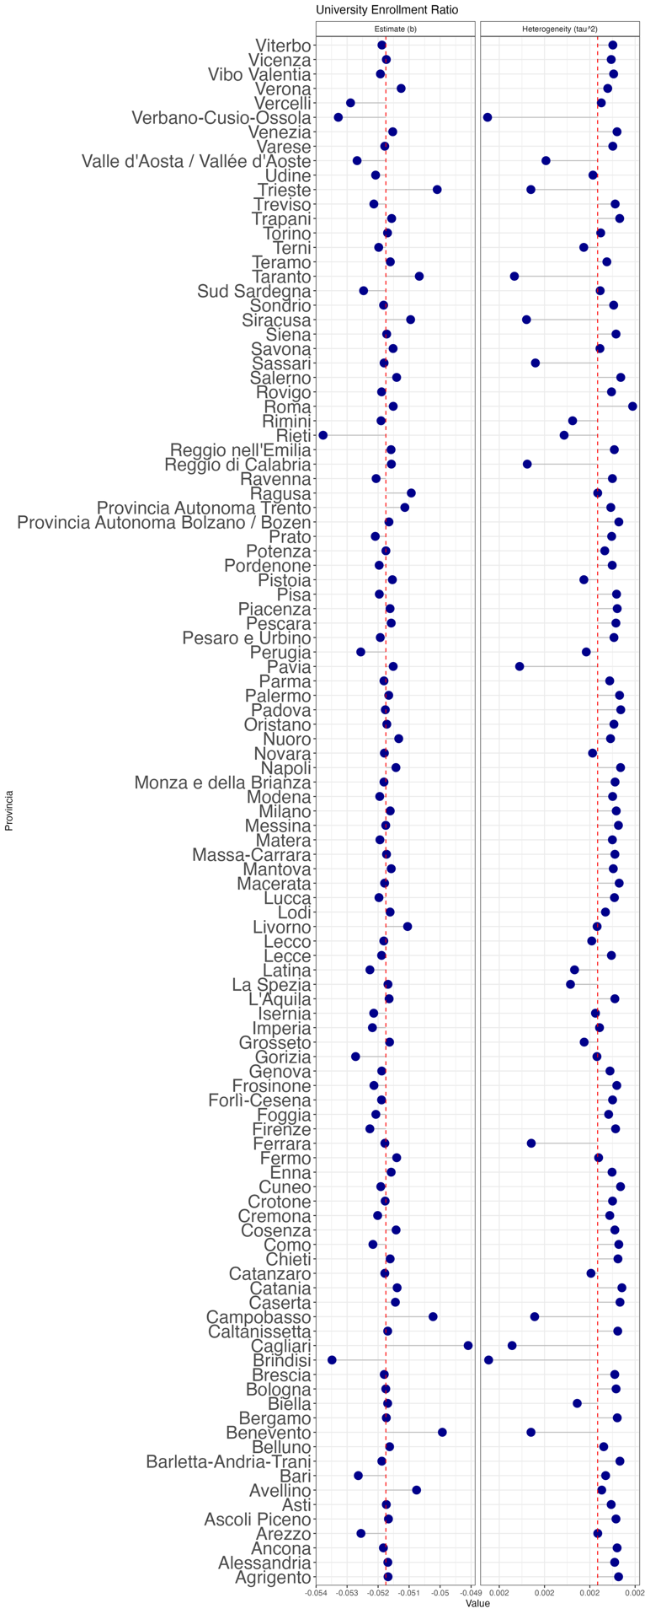

Figure S19
Leave-one-out results for reading (University Enrollment Ratio)
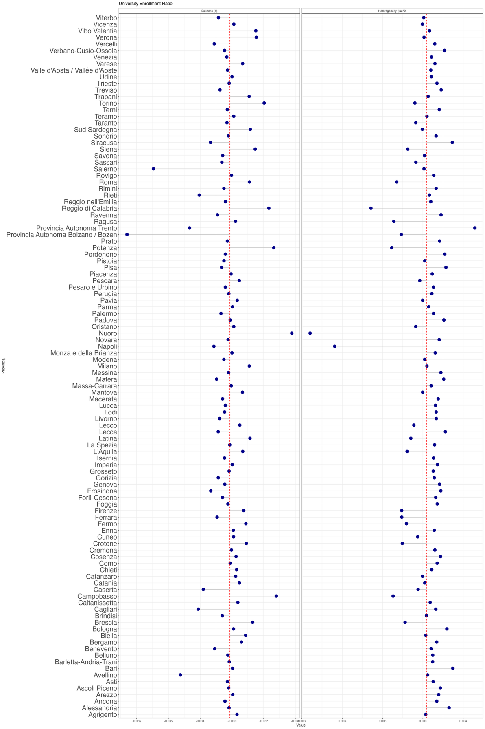

Figure S20
Leave-one-out results for reading (Mean Achievement)
